EMTH211-22S2 Assignment 1

This assignment is due **5:00PM** **Friday 23 September** and is to be handed through the boxes on Level 4 in the Mathematics & Statistics Department (Erskine). If you want to be eligible for the cover sheet meme prizes, **please submit your meme to the Learn dropbox** in the Assignments section. This assignment is worth **10%** of your final grade. You may work **by yourself or with one other person.** If you hand in a joint assignment, you will each be given the same mark. Please complete and attach the cover sheet to your assignment before submitting your assignment.

# Assignment Guidelines

The main purpose of this assignment is to give you a chance to apply what you have learned from lectures to some more involved problems. While assessing you on your ability to write a clear and concise report is not the main goal, there will be some marks set aside for clarity, readability, and grammar (this will be helpful experience for some of the stricter engineering reports in future courses).

Here are a few key guidelines:

* You should not need a large introduction or conclusion. You can assume that the reader has access to the assignment questions, so do not worry about retyping the whole question out again. One or two sentences to explain the background of each question is sufficient for introduction, and you do not need a conclusion for the whole assignment.
* Each question has its own context (even if that context is purely mathematical) and you should answer within that context.
* Explain how you calculated your answers with enough detail to show that you understand the method.
  + You can do this several ways. Consider using a combination of paragraphs, tables, equations, working, diagrams, snippets of code, etc. to describe your methods and decisions.
  + You can assume the reader of your assignment has the basic mathematical knowledge required for this course (e.g. you don’t need to explain what matrix multiplication is).
* Lay out your final answers clearly.
* You should not include large code scripts in the main body of your assignment but including them in appendices would be appropriate.

# Cover sheet

Please use the cover sheet template on the following page for your assignment. The meme is optional, but the best memes may be eligible for a chocolate-y and/or plushy feline prize, as judged by Nic, Luke, Michael and Rua. Memes should be appropriate (refer to the memes shown in lectures for baseline), and (at least tangentially) related to the course. Please also upload your meme to the dropbox on Learn, as we will select the winners from the dropbox.

J`

EMTH211 – Assignment Cover Sheet

|  |  |
| --- | --- |
| Name(s): | Dominic McNulty |
| Student ID(s): | 57881020 |
| Tutorial Group(s): | Friday 3pm |
| Signatures(s): |  |
|  |  |

**This assignment MUST be your own work or the work of a pair.  
STAPLE this page to the front of your assignment.**

**Due:** **5:00PM** **Friday 23 September**

Your (optional) meme here

# Q1

As part of an investigation about which rides are the most popular, you have been tasked with modelling a theme park with attractions labelled A, B, C, D, E, F and G. The layout of the park is given on the following page, with the labelled circles representing the rides (see part (d) below), and the lines representing paths between rides. The behaviour of a typical park visitor is as follows: A visitor will either go on the same attraction again, or they will go to an attraction that is adjacent (connected by a path) to the one they previously rode; chosen at random with the probability that the visitor will go to an adjacent ride with thrice the probability that they will go the same ride again. Thus, for example, if the visitor just went to attraction G, the next ride would be G with a probability of 1/10, B with a probability of 3/10, D with a probability of 3/10, and F with a probability of 3/10.

* 1. What is the long-term probability distribution for the location of the visitor? Give your answer in terms of percentages.
  2. In the long term, which attraction(s) is a visitor most likely to ride three times in a row? What is the probability for this to occur?
  3. What do you think the limitations of modelling park visitor behaviour with a Markov Chain are? This is an open-ended question, where you may want to consider things such as the Markov chain’s convergence speed to long-term behaviour, human behaviour, and the effects of a real-world park layout.
  4. (optional) Draw your best guess at what each ride might look like, where the ride names are:

|  |  |
| --- | --- |
| A | Algebraic Abyss |
| B | Boolean Bumpercars |
| C | Covariance Cove |
| D | Derivative Drop |
| E | Exponential Enterprise |
| F | Fourier Flumes |
| G | Gaussian Gauntlet |

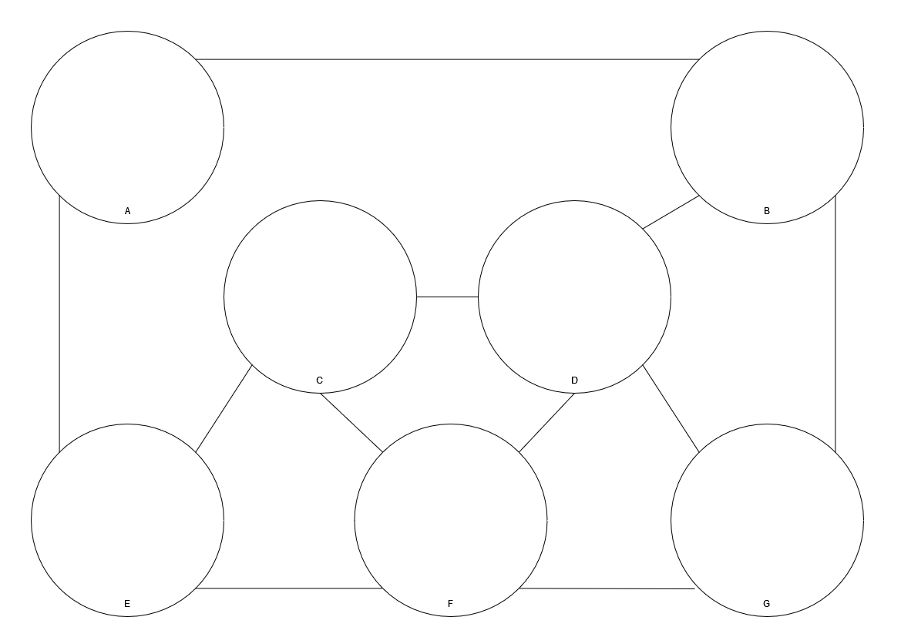

# Q2

You have been tasked with modelling a hypothetical mosquito outbreak in the theme park. Based on (possibly fictional) research done on “mosquito outbreaks in maths-themed theme parks”, the mosquitos would have the following population parameters:

|  |  |  |  |
| --- | --- | --- | --- |
| **Vector entry** | **Age (days)** | **Birth Rate** | **Survival Rate** |
| $$x_{1}$$ | 0-5 | 0 | 0.15 |
| $$x_{2}$$ | 5-10 | 0 | 0.30 |
| $$x_{3}$$ | 10-15 | 0 | 0.50 |
| $$x_{4}$$ | 15-20 | 100 | 0.40 |
| $$x_{5}$$ | 20-25 | 100 | 0.25 |
| $$x_{6}$$ | 25-30 | 100 | 0.25 |
| $$x_{7}$$ | 30-35 | 100 |  |

These age groups correspond to specific stages of a mosquito’s life, where $x_{1}$ are eggs, $x_{2}$ are larvae, $x_{3}$ are pupae, and $x_{4-7}$ are adults.

* 1. Apply the Leslie Model to the mosquito population and model 50 iterations (250 days) of population growth, starting with a population of $x^{(0)}={\left[0, 0, 0, 10, 0, 0, 0\right]}^{T}$. Plot the mosquito populations for each iteration as stacked bar charts. (You may find the following links helpful for plotting stacked bar charts in [Python](https://matplotlib.org/stable/gallery/lines_bars_and_markers/bar_stacked.html) or [Matlab](https://au.mathworks.com/help/matlab/ref/bar.html).)
  2. Comment on whether you think that the mosquito population distribution has approached the theoretical long-term distribution after the 50 iterations of population growth in (a). Clearly explain your answer.
  3. One of the potential options for preventing an outbreak is to effectively lower the birth rate of eggs by culling $x_{1}$. Determine the “harvest” rate required for stopping population growth while only culling $x_{1}$. Confirm this answer by finding the dominant eigenvalue of $L_{h}$, the Leslie matrix with effective birth rates. (You may find pg. 262-267 of Week 5 notes helpful)

# Q3

Let

* 1. Use Gershgorin’s Theorem to locate the eigenvalues of A.
  2. Use the inverse power method to compute *all* the eigenvalues (use a tolerance of 0.01). Your code should be written to run efficiently even if A was very large (e.g. 1000×1000).